

**THE STATE UNIVERSITY OF ZANZIBAR**

**SCHOOL OF COMPUTING, COMMUNICATION AND MEDIA STUDIES DEPARTMENT OF COMPUTER SCIENCE AND INFORMATION TECHNOLOGY FINAL YEAR PROJECT SYSTEM DOCUMENTATION FORMAT 2024**

|  |  |
| --- | --- |
| COURSE CODE | CS |
| COURSE TITLE | FINAL YEAR PROJECT |
| DATE | 20/08/2024 |
| SUPERVISOR | DR. OMAR KOMBO |
| STUDENT NAME | ABDUL-RAHMAN SHAIBU KHEIR |
| YEAR | THIRD YEAR |
| REGISTRATION NUMBER | BCS/16/21/011/TZ |

###### ACKNOWLEDGEMENT

Firstly, I would like to thank almighty God for empowering me and enabling his guidance to me on everything as well as giving me good health and power to accomplish my report.

I would like to express my gratitude to all my lectures at SUZA for their not only proper cooperation but also appreciation, and to many individuals who have willingly contributed to an ultimate success of my project system documentation.

I wish to express my special thanks to my beloved supervisor ***DR. OMAR KOMBO*** for his both encouragement motivation and continuous support simultaneously with his advice, through all the time. Without his support, I could not have completed this completed report.

Also, I would like to give my appreciation to THE STATE UNIVERSITY OF ZANZIBAR (SUZA) that is has been effortful in lecturing for all semesters.

###### ABSTRACT

This is a report concerning with **Web Development** of University Cleaners Management.

**The first two weeks** out of four months in my final year project system documentation format was about providing short and clear description and intention of my project.

Providing brief investigation of the system under consideration gives a clear picture of how actually the physical system is? Brief analysis or summary of the problems identified relating to the project or issues to be addressed by the project.

Explaining the scenarios of how my proposed system will be used and to articulate how this solution is better than the current practice. Describing the envisioned benefits of my proposed solution. Explaining the scope/main functions that should be covered by proposed solution Also explaining the objectives, project background and motivation.

**The second two weeks** out of four months in my final year project system documentation format was about methodology based on software development approach, software development life cycle model, and system architecture and software development tools.

**The fifth weeks** out of four months in my final year project system documentation format was about requirement analysis and modeling. Requirement Here will touch requirement determination and structuring.

**The last weeks** are about system design, system implementation and testing, conclusions, recommendations challenges and references.

**Generally**, Web Development of University Cleaners Management System will be divided into 6 chapters namely chapter one, chapter two chapter three chapter four chapter five and chapter six, however sub topics respectively.

Chapter one, introduction to University Cleaners Management System, project documentation format start and end date.

And the rest explain about methodology, requirement analysis and modeling, system design and system implementation and testing.

**Table of Contents**

[ACKNOWLEDGEMENT 1](#_Toc8214)

[ABSTRACT 2](#_Toc27880)

[LIST OF ABBREVIATIONS 5](#_Toc11146)

[UCMS 5](#_Toc3607)

[CHAPTER 1 6](#_Toc15382)

[DESCRIPTION OF THE PROJECT 6](#_Toc29007)

[Problem Statement 6](#_Toc28007)

[Problems, Solution, and Scope 6](#_Toc13187)

[Key Objectives 8](#_Toc22901)

[Project Background and Motivation 8](#_Toc15303)

[Technical Feasibility 9](#_Toc14335)

[CHAPTER 2 11](#_Toc15193)

[METHODOLOGY 11](#_Toc15596)

[Software development life cycle model (SDLC) 11](#_Toc23465)

[System Architecture 12](#_Toc15875)

[CHAPTER 3 14](#_Toc8309)

[Functional requirements 14](#_Toc19722)

[Non – functional requirements 15](#_Toc14904)

[Use-case diagram 16](#_Toc3547)

[Entity relationship diagram 19](#_Toc9631)

[CHAPTER 4 20](#_Toc14776)

[Data Description 21](#_Toc8128)

[User Interface Design 23](#_Toc18719)

[CHAPTER 5 24](#_Toc20972)

[Database implementation 28](#_Toc11012)

[Internal Schema of database 29](#_Toc23566)

[TESTING 29](#_Toc32046)

[REPORTING TESTING 30](#_Toc16582)

[What is not covered 33](#_Toc30212)

[CHAPTER 6 34](#_Toc14184)

[Conclusion 34](#_Toc27735)

[Recommendations 34](#_Toc19688)

[References 35](#_Toc11528)

###### LIST OF ABBREVIATIONS

API APPLICATION PROGRAMMING INTERFACE

ERD ENTITY RELATIONAL DIAGRAM

FK FOREIGN KEY

PK PRIMARY KEY

S/N SERIAL NUMBERS

SLDC SOFTWARE DEVELOPMENT LIFE CYCLE MODEL

SRS SOFTWARE REQUIREMENT SPECIFICATION

SUZA THE STATE UNIVERSITY OF ZANZIBAR.

UCMS UNIVERSITY CLEANERS MANAGEMENT SYSTEM

###### CHAPTER 1

### INTRODUCTION ABOUT THE PROJECT

#### DESCRIPTION OF THE PROJECT

The University Cleaners Management System (UCMS) is designed to streamline and manage cleaning services provided to various client organizations. This system facilitates the management of cleaning companies, their staff, client organizations, client sites, tools, and related complaints and attachments. It ensures efficient handling of staff complaints, tracking of tools and equipment, and effective communication between cleaning companies and client organizations.

#### Problem Statement

Managing cleaning services involves coordinating multiple entities such as cleaning companies, staff, client organizations, and their sites. Current manual or inefficient digital systems often lead to issues such as:

* Inefficient tracking of cleaning tasks and staff assignments.
* Poor management and resolution of staff complaints.
* Difficulty in monitoring and maintaining tools and equipment.
* Challenges in maintaining and accessing records and attachments related to complaints.

#### Problems, Solution, and Scope

**Problems:**

* **Inefficient Management:** Managing multiple entities like cleaning companies, staff, client organizations, and tools can be cumbersome without a centralized system.
* **Complaint Handling:** Staff complaints and their resolution processes are often poorly managed, leading to unresolved issues and dissatisfaction.
* **Tool Tracking:** Difficulty in tracking tools and equipment across different client sites.
* **Record Management:** Challenges in managing and accessing attachments related to complaints.

**Solution:** The UCMS addresses these problems by providing a comprehensive digital platform with the following features:

* **Centralized Management:** A centralized system to manage cleaning companies, staff, client organizations, and client sites.
* **Complaint Management:** An integrated system for submitting, tracking, and resolving staff complaints.
* **Tool Tracking:** Efficient tracking of tools and equipment assigned to different client sites.
* **Attachment Management:** A structured way to handle and access attachments related to complaints.

**Scope:** The scope of the UCMS project encompasses the planning, design, development, and implementation of a comprehensive system to manage cleaning company operations, staff, client organizations, sites, tools, and related complaints and attachments. The project aims to provide a centralized platform to streamline and enhance the management of these entities through an integrated database system.

###### Key Objectives

* **Comprehensive Management System:** Develop a robust system to manage cleaning companies, staff, client organizations, sites, tools, complaints, and attachments.
* **Role-Based Access Control:** Implement role-based access control to ensure data security and integrity, granting appropriate permissions based on user roles.
* **Task Management:** Incorporate task management features to assign tasks to cleaning staff, track progress, and ensure efficient task completion.
* **Operational Efficiency:** Enhance overall efficiency, transparency, and accountability in university cleaning operations, contributing to a cleaner and safer environment for all stakeholders.

#### Objectives

* **Streamline Operations:** Create an efficient and user-friendly system for managing cleaning services and related entities.
* **Enhance Complaint Handling:** Provide a robust mechanism for managing and resolving staff complaints.
* **Improve Tracking:** Enable effective tracking of tools and equipment across various client sites.
* **Centralize Record Management:** Centralize the management of records and attachments, making them easily accessible and manageable.

#### Project Background and Motivation

The significance of this project lies in bridging the gap between existing manual systems and the potential for a technology-driven approach to manage university cleaners. The motivation stems from observed deficiencies in previous attempts. By addressing the shortcomings of manual processes, this project aims to enhance operational efficiency and elevate the quality of service delivery. The overarching goal is to create a transformative solution that not only addresses existing gaps in cleaners management but also sets an instance for efficient support staff management within university settings. The identified knowledge gaps and previous studies serve as the foundation for this project's approach to effective cleaner management in academic institutions.

Managing university cleaners has traditionally relied on manual processes for crucial aspects such as registration, work area allocation, tool monitoring, and complaint management. Previous attempts have shown limited integration of technology, often resulting in inefficient management systems and inadequate resolution of challenges in accurately managing cleaner information and tasks within university settings.

#### Technical Feasibility

The technical feasibility of the UCMS project assesses the practicality of the proposed system based on current technology and resources. The system will utilize modern web technologies such as React for the frontend and Spring Boot for the backend, ensuring scalability, maintainability, and performance. Integration with existing university IT infrastructure will be evaluated to ensure compatibility and minimal disruption. Additionally, the project will leverage robust security protocols to protect sensitive data, ensuring compliance with industry standards.

#### Operational Feasibility

Operational feasibility examines the ability of the university and associated cleaning companies to effectively implement and utilize the UCMS. The system will streamline operations, enhance communication, and improve efficiency in managing cleaning tasks, staff, and complaints. Training programs will be conducted to ensure that all users, including administrators, staffs and cleaning staff, can effectively use the system. User feedback will be incorporated into the development process to ensure the system meets the operational needs of all stakeholders.

#### Legal Feasibility

Legal feasibility assesses the compliance of the UCMS project with relevant laws and regulations. The system will adhere to data protection and privacy laws to ensure the secure handling of personal and sensitive information. Contracts and agreements with cleaning companies and client organizations will be reviewed to ensure they align with the implementation of the new system. Any legal constraints or requirements will be identified and addressed to mitigate potential risks.

#### Economic Feasibility

Economic feasibility evaluates the cost-effectiveness and financial viability of the UCMS project. A detailed cost-benefit analysis will be conducted, considering the initial development costs, ongoing maintenance, and potential savings from increased efficiency and reduced manual workload. The system is expected to provide significant and improved operational efficiency, better resource management, and enhanced accountability.

###### CHAPTER 2

###### METHODOLOGY

**Software Development Approach**

In this project, agile development approach has been adopted as the model of software development.

At its core, Agile modeling emphasizes transparency, iteration, and empowerment. ***Transparency*** ensures that everyone involved in the project has a clear understanding of the goals, progress, and challenges. ***Iteration*** means that development occurs in small, manageable increments, allowing for rapid feedback and adaptation. Empowerment encourages teams to take ownership of their work, fostering creativity and innovation.

One of the key **advantages** of the Agile approach is its preference for face-to-face communication enabling better cooperation, welcoming changes, integrating them smoothly into ongoing development cycles and facilitating responsiveness.

However, the Agile model does have its **challenges**. For instance, in case of some software deliverable, especially the large ones, it is difficult to assess the effort required at the beginning of the software development life cycle.

Software development life cycle model (SDLC)

**SDLC**: Is the process of developing, modifying, maintaining, and replacing a software system. The following are the steps for software development life cycle:

* Planning: In the planning phase, the UCMS project manager and business analyst collected requirements from stakeholders regarding how the UCMS will work and what features it requires
* Designing: The Software Requirements Specification (SRS) documents were sent to the UCMS software development team at this stage. Then, the development team carefully reviewed the document to understand client requirements.
* Development: At this stage developers involved on creating APIs required and adding various functionalities to UCMS.
* Testing: In this step, the tester performed system testing to ensure that the UCMS is working correctly without some bugs.
* Deployment: Lastly, the developers deployed the codes and offer end-users the final version of the UCMS.

System Architecture

A system Architecture is the conceptual model that defines the structure, behavior and more views of the system. An architecture description is a formal description and representation of a system, organized in a way that support reasoning about the structures and behaviors of the system.

The system architecture of the project is **Three-Tier Architecture**

* **Presentation Tier**: A React frontend that interacts with the user.
* **Business Logic Tier**: Spring Boot backend that handles the application logic and communicates with the database.
* **Data Tier**: MySQl database that stores the application's data.

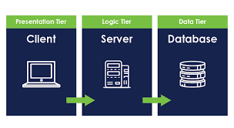

**Software development tools**

Software development tool: is a computer program that software developers use to create, debug, maintain, or otherwise support otherwise support other programs and applications. The following are the programming tools will used in the system:

* • Programming tools
* ➢ Front-end: JavaScript programming language.
* ➢ Back-end: Java programming language.
* • List of tools
* ➢ Front-end: React library.
* ➢ Back-end: Spring boot framework.
* ➢ Database: MySQL Driver.
* • IDEs
* ➢ Front-end: Vs-code.
* ➢ Back-end: IntelliJ IDEA Community.
* Version Control: Git for version control and collaboration

###### 

###### CHAPTER 3

**REQUIREMENTS ANALYSIS AND MODELING**

***Requirements analysis*** is the process of determining user expectations for a new or modified product.

***Requirements modeling*** are the process used in software development projects where requirements and solutions constantly evolve through collaborative efforts and teamwork.

***Requirement determination***

Involves studying the existing system and gathering details to find out what are the

requirements, how it works and where improvements should be made.

***Information gathering techniques***

Are repeated processes that are the used to create and organize data across

different kinds of sources.

During information gathering , I used the following techniques:

* ➢ Interviewing: Stakeholders, participants and experts are interviewed to

identify risks.

###### Functional requirements

|  |  |
| --- | --- |
| REQ ID | **REQUIREMENTS DESCRIPTION** |
| REQ 0001 | The system shall allow staffs to register themselves |
| REQ 0002 | The system shall allow staffs to submit their complains to company staffs’s client organisation |
| REQ 0003 | The system shall allow staffs to attach their complains to company staffs’s client organisation |
| REQ 004 | The system shall allow administrator to allocate company staffs to their client organization |
| REQ 005 | The system shall allow administrator to allocate company staffs to the client sites from their client organization |
| REQ 006 | The system shall allow administrator to manage tools in a client sites |
| REQ 007 | The system shall allow staff to update their personal information |
| REQ 008 | The system shall allow administrators to view and generate reports on staff complaints |
| REQ 009 | The system shall allow staff to upload and manage attachments related to their complaints. |
| REQ 010 | The system shall allow administrators to manage the list of client organizations and their details. |
| REQ 011 | The system shall allow administrators to manage the list of client sites and their details. |

###### Non – functional requirements

This defines system attributes such as security, reliability, performance, maintainability, scalability and usability. They serve as constraints or restrictions on the design of the system across the different backlogs.

|  |  |
| --- | --- |
| **REQ ID** | **REQUIREMENTS DESCRIPTION** |
| REQ 0001 | Scalability: The system must be scalable enough to support 100000 visits at the same time while maintaining optimal performance. |
| REQ 0002 | Portability: A program running on windows must be able to run on UNIX without any change in its behavior and performance. |
| REQ 0003 | Reliability: The system must perform without failure in 95 percent of use cases during a month. |
| REQ 0004 | Availability: The web interface must be available 99.98 percent of the time every month during a day. |
| REQ 0005 | Usability: The error rate of users submits their cases evidence must not exceed 10 percent. |
| REQ 0006 | Security: The password must be encrypted. |

**Requirement Structuring**

It is a hierarchical, usually tree-shaped description of all project requirements which must be present in the end product in order to deliver the expected business value.

**Process Modelling**

It is a framework used by cognitive psychologists to explain and describe the processes of the human brain

**OBJECT ORIENTED APPROACH**

Use-case diagram to illustrate how current system is implemented.

A *usecase diagram* is a graphical depiction of a user’s possible interactions with a system.

***Use-case model (use-case diagram and use-case description) to illustrate how proposed system is implemented***

The Use-case model is defined as a model which is used to show how users interact with the system in order to solve a problem.

The use-case model defines the user’s objective, the interactions between the system and the user, and the system’s behavior required to meet these objectives.

###### Use-case diagram

**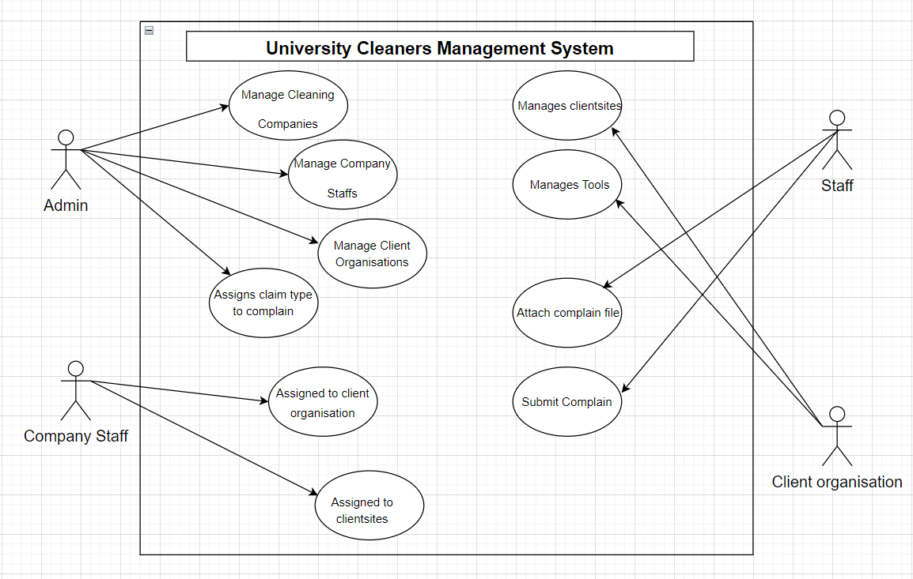**

**Use-Case Description**

|  |  |  |
| --- | --- | --- |
| **S/N** | **ACTOR** | **DESCRIPTIONS** |
| 1 | Staff | This is a staff from the client site who can either submit or attach complain |
| 2 | Client organisation | This is an organisation from a cleaning company that is responsible for managing both tools and client sites |
| 3 | Company staff | This is a company staff from cleaning company who is  assigned to client organisation as well as client sites |
| 4 | Admin | Is the one who is responsible for managing cleaning company,company staffs, client organisations and  Assigning complain type |

**Data Modelling**

Data Modelling is the process of creating a data model for an information system by applying certain formal techniques.

**OBJECT ORIENTED APPROACH**

**Class diagram**

Class diagram is a type of static structure diagram that describes the structure of a system by showing the system’s classes, their attributes, operations and the relationships among the objects.

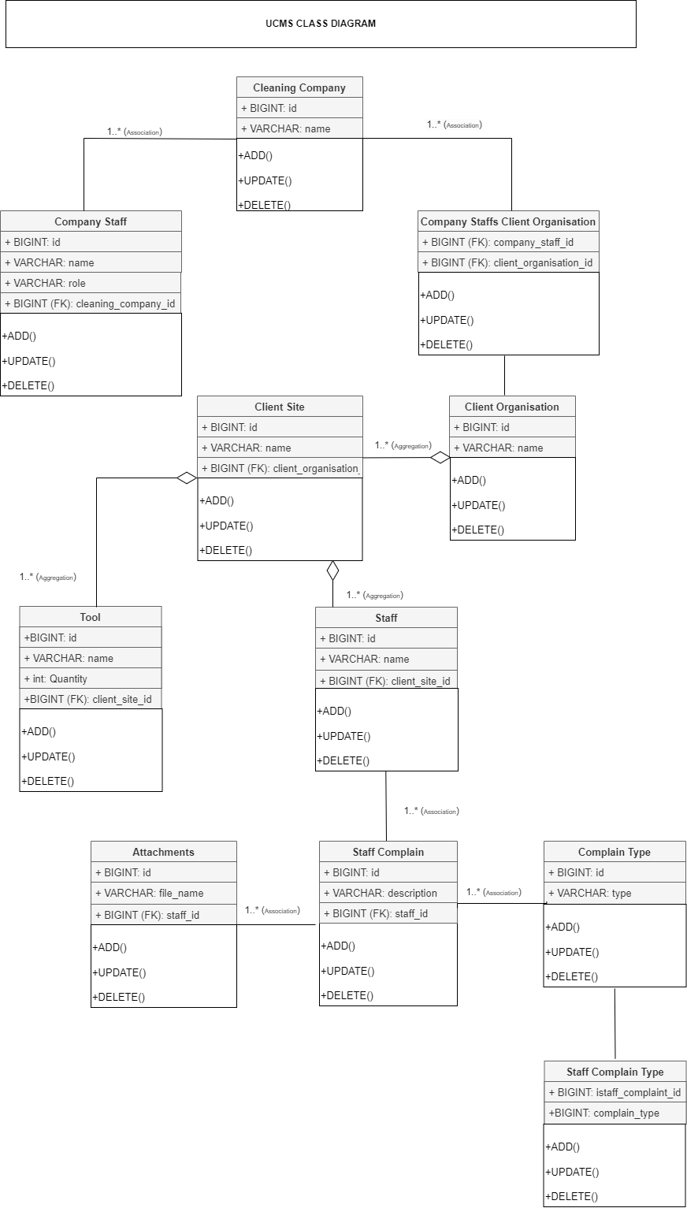

###### Entity relationship diagram

Is a graphical representation that depicts relationships among people, objects, places, concepts or events within an information technology system.

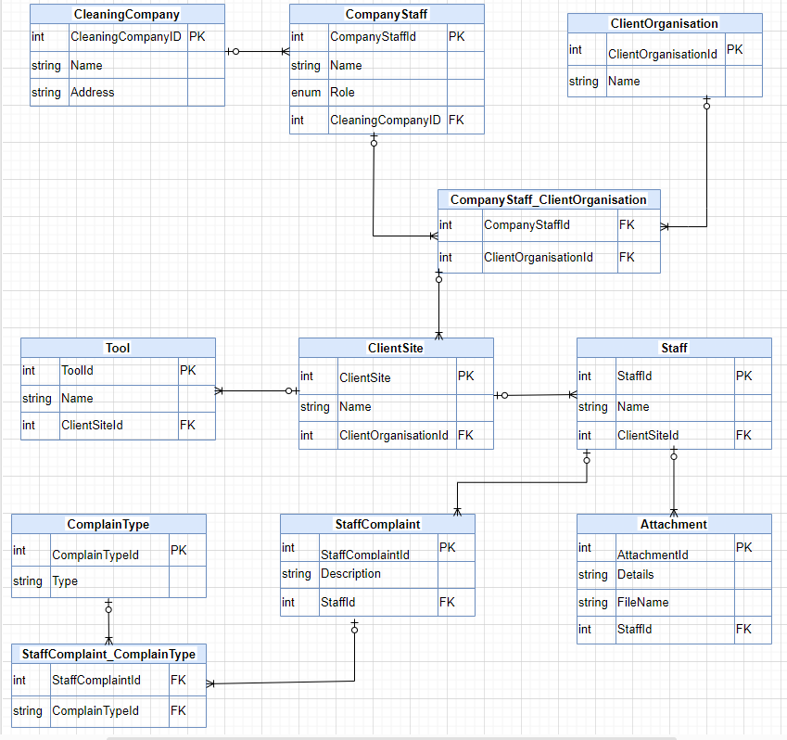

**Sequence diagram**

* It is high-level interactions between user of the system and the system, between the system and other systems, or between subsystems (sometimes known as system sequence diagrams)
* It shows the interaction that takes place in a collaboration that either realizes a use case or an operation (instance diagrams or generic diagrams)

**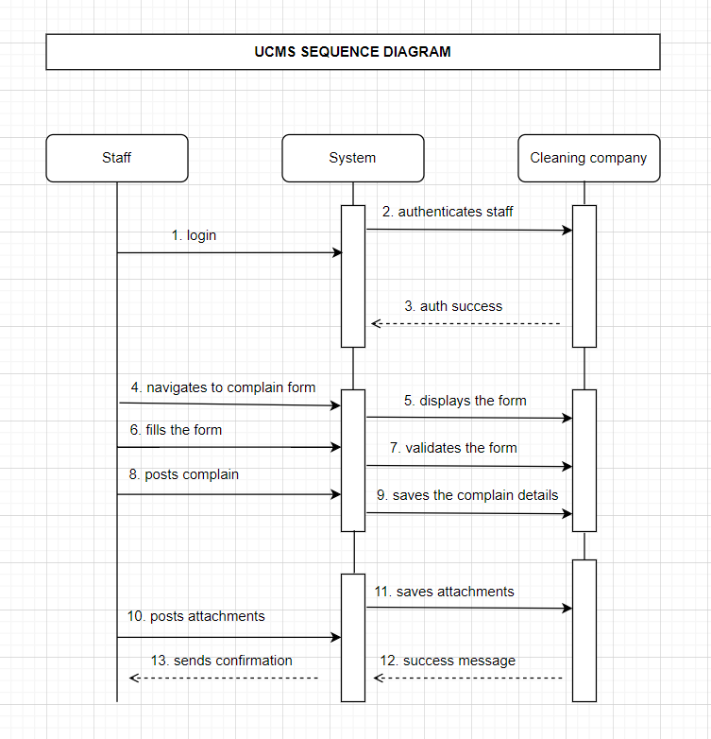**

###### CHAPTER 4

###### **System Design**

**Architectural design: a description of the architecture of the program**

Is the process of defining a collection of hardware and software components and their interface to establish the framework for the development of a computer system. This helps stakeholders to understand and analyze how the system will achieve essential qualities such as modifiability, availability and security.

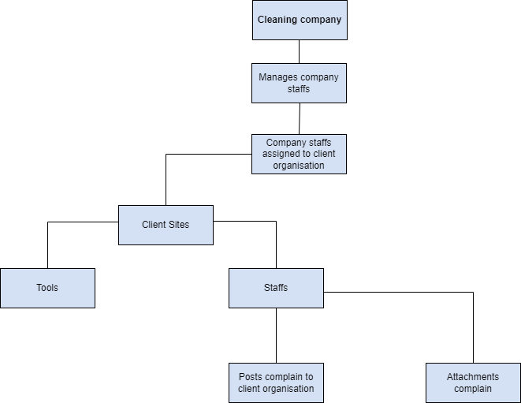

###### Data Description

Table Name: The name for the Table.

Column Name: The predefined name for the column.

Description: A detailed description of the contents and purpose for the column

Data Type & Size: The predefined characteristics for the column.

**Table Name: Cleaning company**

|  |  |  |  |
| --- | --- | --- | --- |
| **S/N** | **COLUMN NAME** | **DESCRIPTION** | **DATA TYPE** |
| **1** | id | Primary key | BIGINT |
| **2** | name | Company name | VARCHAR |

**Table Name: Company staff**

|  |  |  |  |
| --- | --- | --- | --- |
| **S/N** | **COLUMN NAME** | **DESCRIPTION** | **DATA TYPE** |
| **1** | id | Primary key | BIGINT |
| **2** | name | Staff name | VARCHAR |
| **3** | role | Staff role | VARCHAR |
| **4** | cleaning\_company\_id | Foreign key to cleaning\_company | BIGINT |

**Table Name: Client organisation**

|  |  |  |  |
| --- | --- | --- | --- |
| **S/N** | **COLUMN NAME** | **DESCRIPTION** | **DATA TYPE** |
| **1** | id | Primary key | BIGINT |
| **2** | name | Organisation name | VARCHAR |

**Table Name: Client site**

|  |  |  |  |
| --- | --- | --- | --- |
| **S/N** | **COLUMN NAME** | **DESCRIPTION** | **DATA TYPE** |
| **1** | id | Primary key | BIGINT |
| **2** | name | Site name | VARCHAR |
| **3** | client\_organisation\_id | Foreign key to client\_organisation | BIGINT |

**Table Name: Tool**

|  |  |  |  |
| --- | --- | --- | --- |
| **S/N** | **COLUMN NAME** | **DESCRIPTION** | **DATA TYPE** |
| **1** | id | Primary key | BIGINT |
| **2** | name | Tool name | VARCHAR |
| **3** | client\_site\_id | Foreign Key to oclient\_site | BIGINT |

**Table Name: Staff**

|  |  |  |  |
| --- | --- | --- | --- |
| **S/N** | **COLUMN NAME** | **DESCRIPTION** | **DATA TYPE** |
| **1** | id | Primary key | BIGINT |
| **2** | name | Tool name | VARCHAR |
| **3** | client\_site\_id | Foreign Key to oclient\_site | BIGINT |

**Table Name: Staff complain**

|  |  |  |  |
| --- | --- | --- | --- |
| **S/N** | **COLUMN NAME** | **DESCRIPTION** | **DATA TYPE** |
| **1** | id | Primary key | BIGINT |
| **2** | description | Complain description | VARCHAR |
| **3** | staff\_id | Foreign Key to staff | BIGINT |

**Table Name: Attachment**

|  |  |  |  |
| --- | --- | --- | --- |
| **S/N** | **COLUMN NAME** | **DESCRIPTION** | **DATA TYPE** |
| **1** | id | Primary key | BIGINT |
| **2** | name | Tool name | VARCHAR |
| **3** | staff\_id | Foreign Key to staff | BIGINT |

**Table Name: Complain type**

|  |  |  |  |
| --- | --- | --- | --- |
| **S/N** | **COLUMN NAME** | **DESCRIPTION** | **DATA TYPE** |
| **1** | id | Primary key | BIGINT |
| **2** | type | Complain type | VARCHAR |

**Table Name: Company-staff\_Client-organisation**

|  |  |  |  |
| --- | --- | --- | --- |
| **S/N** | **COLUMN NAME** | **DESCRIPTION** | **DATA TYPE** |
| **1** | Company\_staff\_id | Foreign key to company\_staff | BIGINT |
| **2** | Client\_organisation\_id | Foreign Key to client\_organisation | BIGINT |

**Table Name: Staff-complain\_Complain-type**

|  |  |  |  |
| --- | --- | --- | --- |
| **S/N** | **COLUMN NAME** | **DESCRIPTION** | **DATA TYPE** |
| **1** | Staff\_complain\_id | Foreign key to staff\_complain | BIGINT |
| **2** | Client\_organisation\_id | Foreign key to complain\_type | BIGINT |

###### 

###### User Interface Design

Is the design of user interfaces for machines and software such as computers, mobile devices and other electronic devices with the focus on maximizing usability and the user experience.

**Interface design sample**

Here focuses on expecting what users might need to do and ensuring that the interface has elements that are easy to access, understand and use to facilitate those actions.

**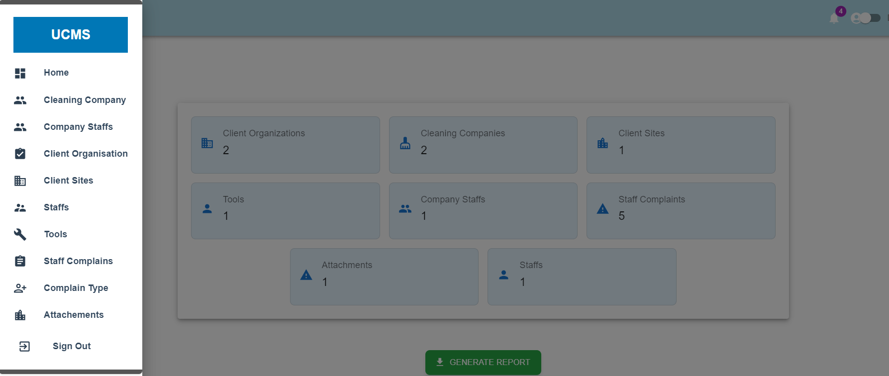**

###### CHAPTER 5

**System implementation and testing**

**Technologies**

A general term covering the development methods, programming languages and tools to support them that may be used in the development of software. The technologies I will use in my system will into two categories, frontend and backend. For frontend I will use **React library** with JavaScript and **Spring Boot** for backend

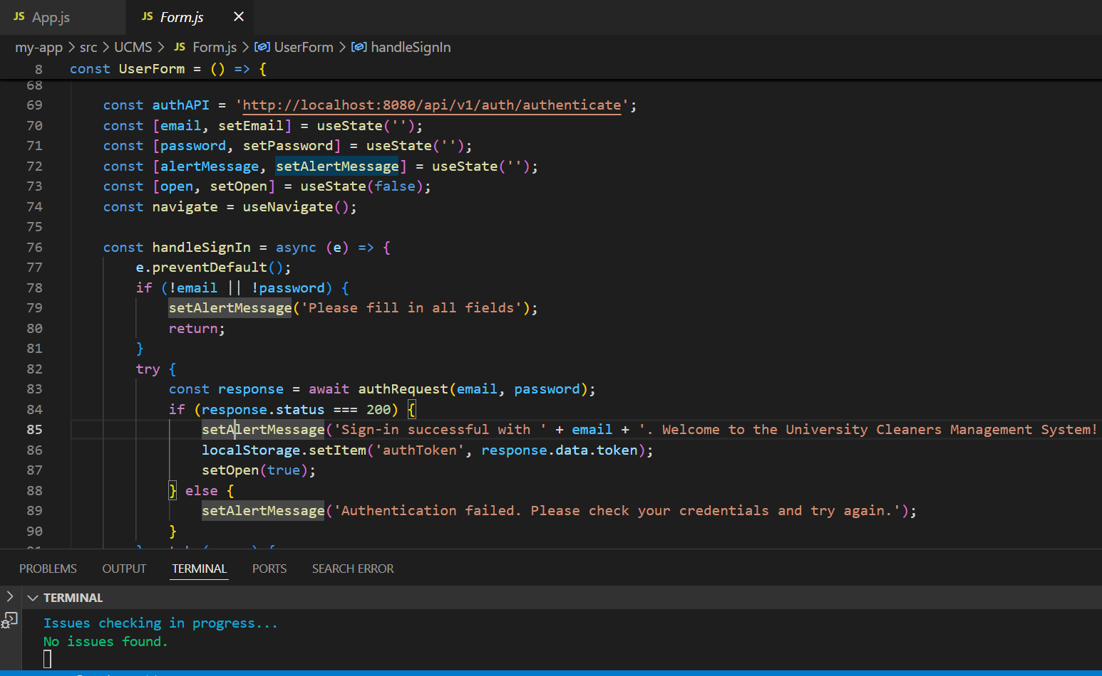

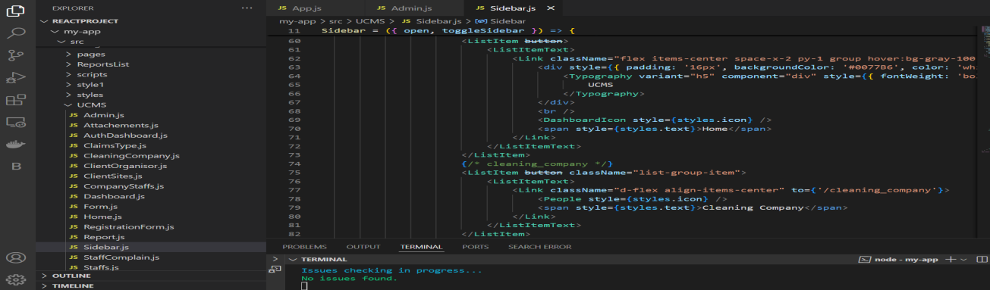

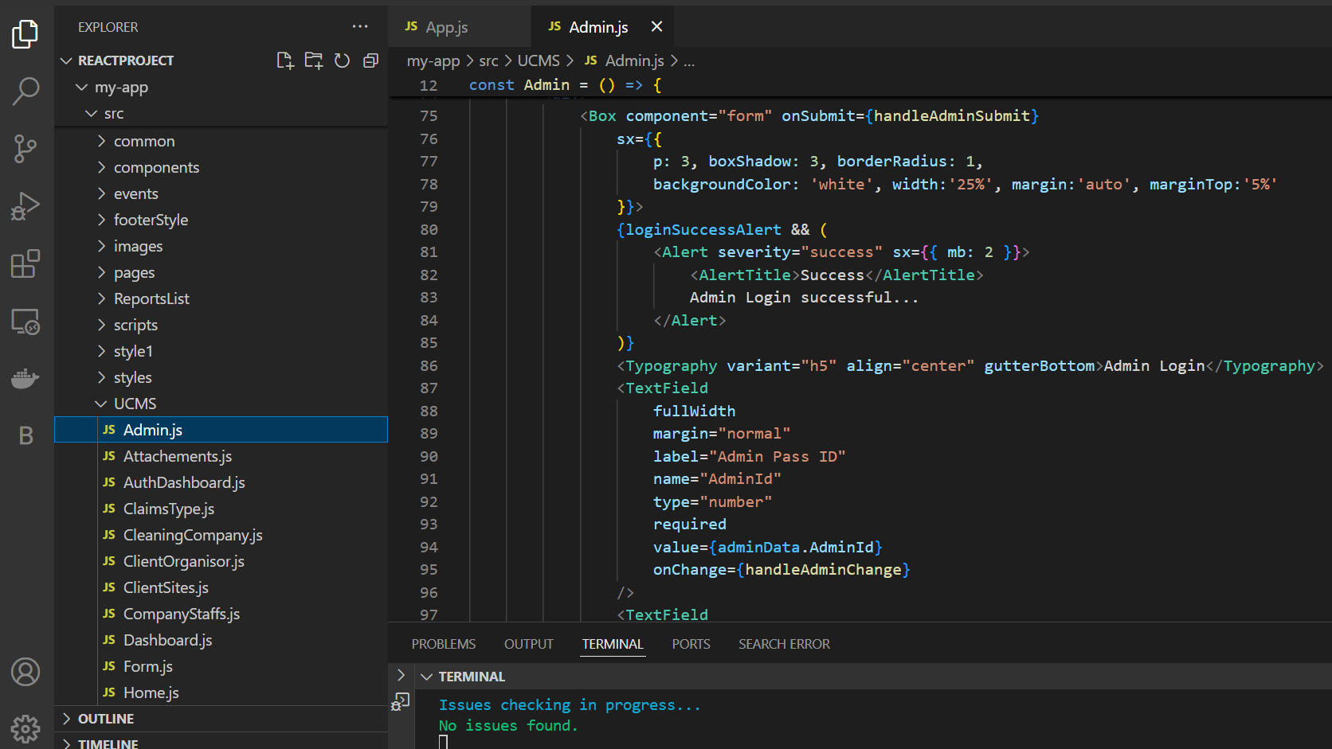

**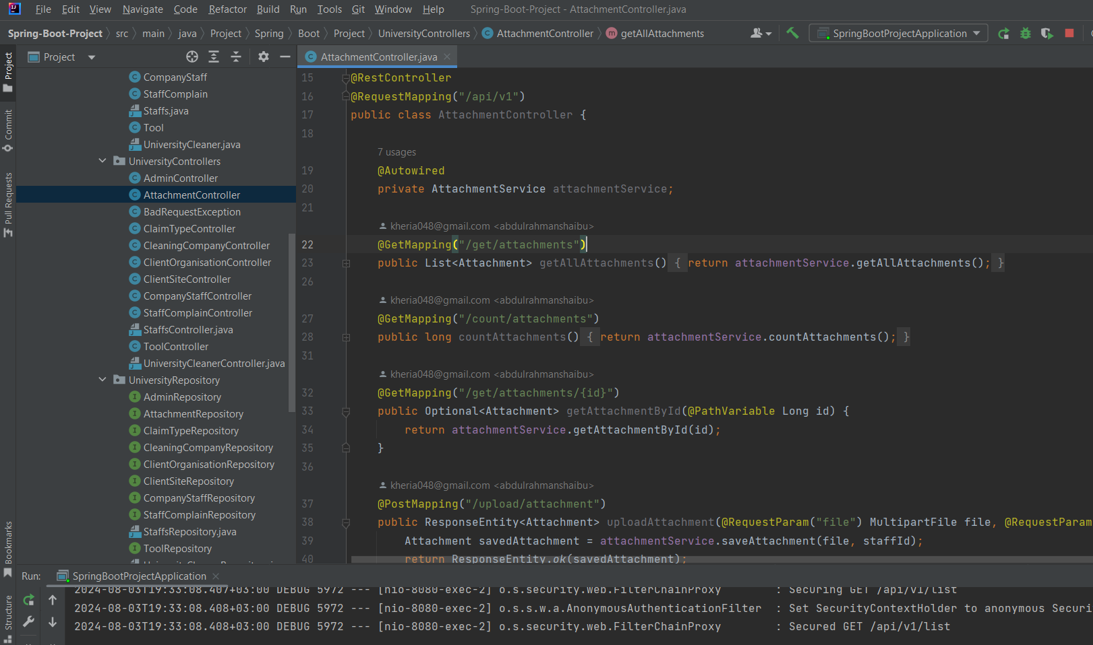**

**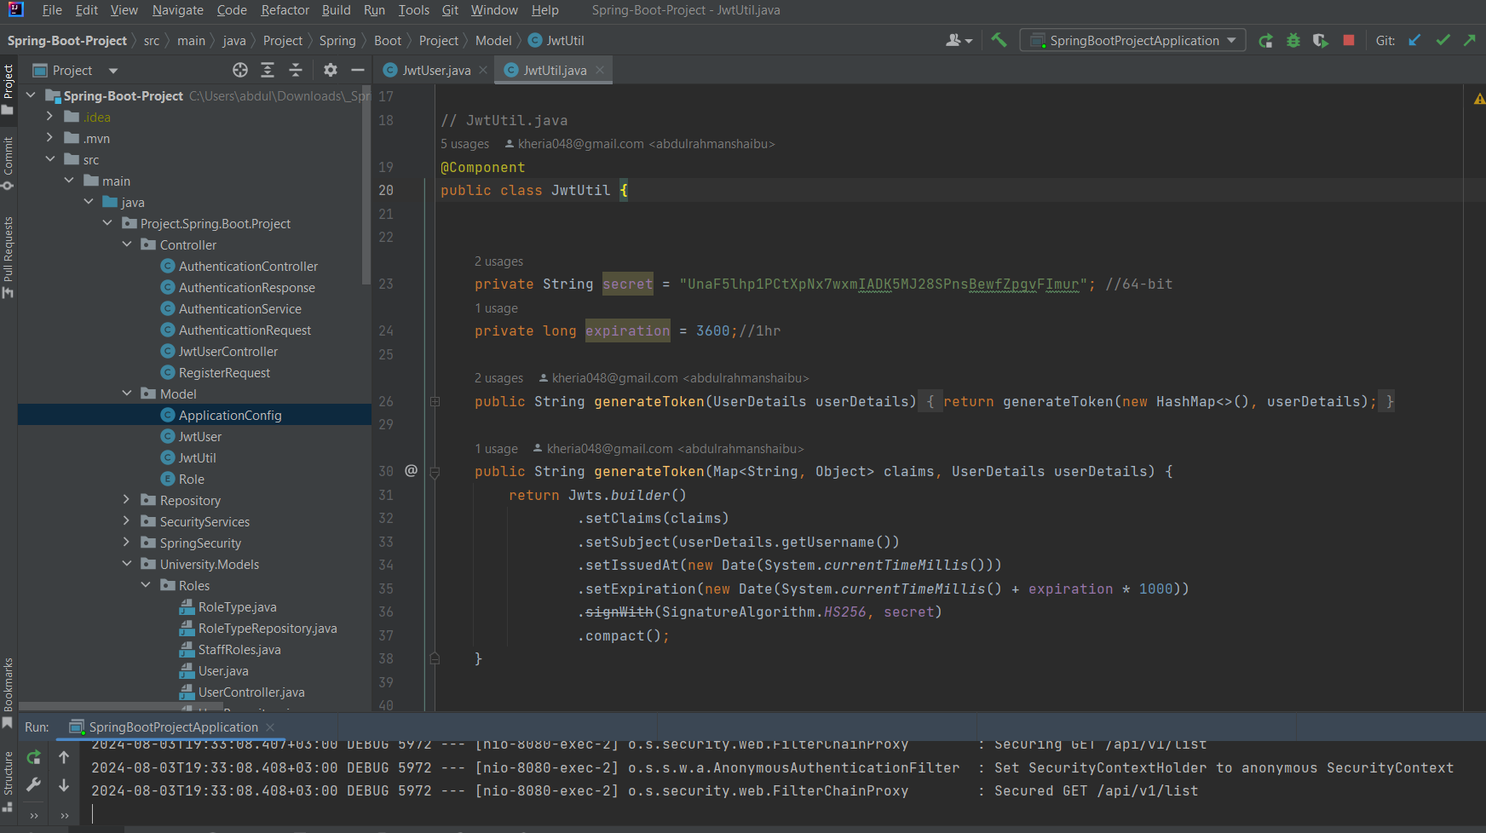**

###### Database implementation

A database implementation is the process of installing database software, performing,

configuration and customization, running and testing the database and then integrating it with applications. Finally, the implementation process involves training the users.

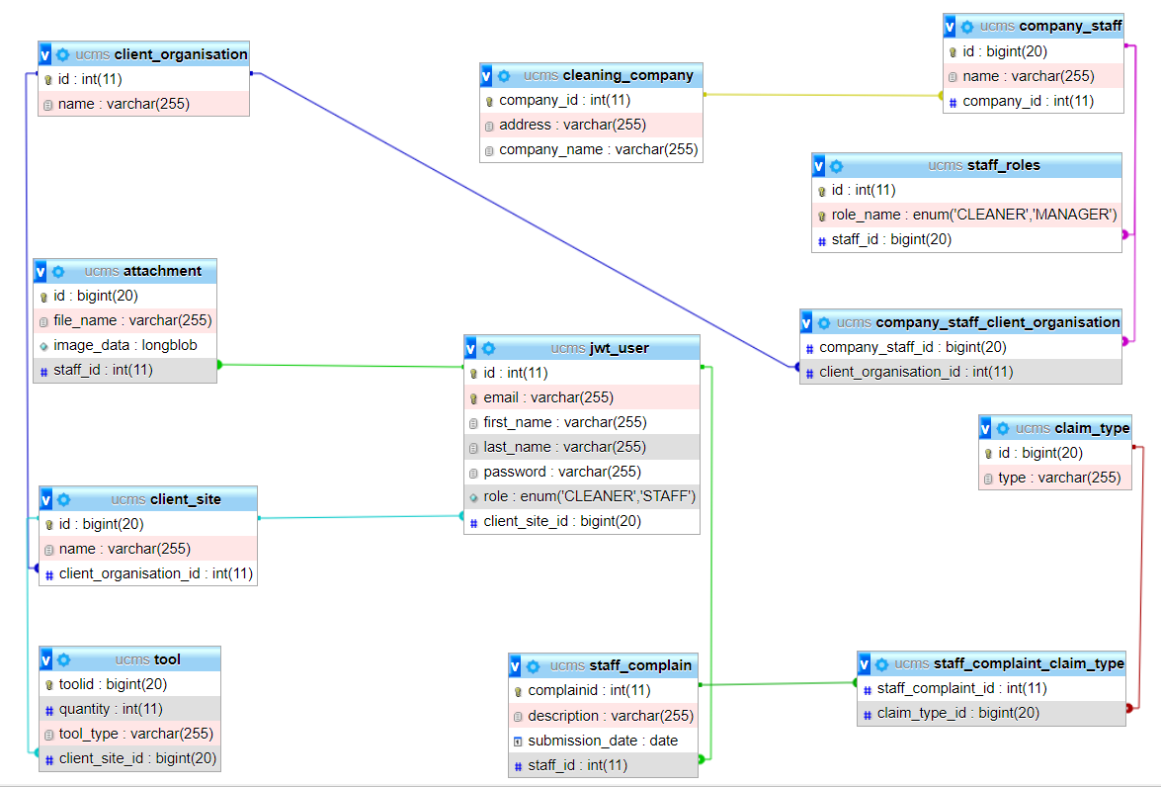

**Data Dictionary**

This is the collection of names, definitions and attributes about data elements that are being used or captured in a database, information system, or a part of a research project.

Internal Schema of database **(database schema)**

Database schema: Is the structure of a database described in a formal language

supported by the database management system. The term schema refers to the

organization of data as a blueprint of how the database is constructed.

The internal schema is also known as physical schema. It uses the physical data model. It is used to define that how the data will be stored in a block.

**cleaning\_company** (id(pk), name)

**company\_staff** (id(pk), name, role, cleaning\_company\_id(fk))

**client\_organisation** (id(pk), name)

**client\_site** (id(pk), name, client\_organisation\_id(fk))

**tool** (id(pk), name, client\_site\_id(fk))

**staff** (id(pk), name, client\_site\_id(fk))

**staff\_complain** (id(pk), description, staff\_id(fk))

**attachment** (id(pk), file\_name, staff\_id(fk))

**complain\_type** (id(pk), type)

**company\_staff\_client\_organisation**(company\_staff\_id(fk),client\_organisation\_idk))

**staff\_complaint\_complain\_type** (staff\_complaint\_id(fk), complain\_type\_id(fk)

###### TESTING

System testing is testing conducted on a complete integrated system to evaluate the system’s compliance with its specified requirements. Takes as input, all of the integrated components that have passed integration testing.

* ➢ Yes, each functionality of the system produce an expected output because, the system contains all the functional specifications which form a basis for the entire test to be conducted. And contains the information about how the system will be perceived from a business process perspective.
* ➢ Yes, the system responds with invalid data entry, when you enter an invalid value or do not enter a value for a required field.
* ➢Yes, the system responds with incorrect login credentials and this refers to your login details; email address and password when one among of these or both has entered incorrect into login form. Also may happen when account is locked out.
* ➢ Yes, my system restricts with user to perform non-privileged functionalities, non-privileged users can only modify the report form while super-user can change password, login to the system to view all reported cases and to work with. All are done by using enhanced security in order to prevent users from choosing their own passwords and get access as super-user.
* ➢ Yes, I have implemented the system using the proposed techniques and development approaches which is agile development approach. Where, agile modelling is a methodology for modeling and documenting software systems based on best practices.

###### Reporting testing

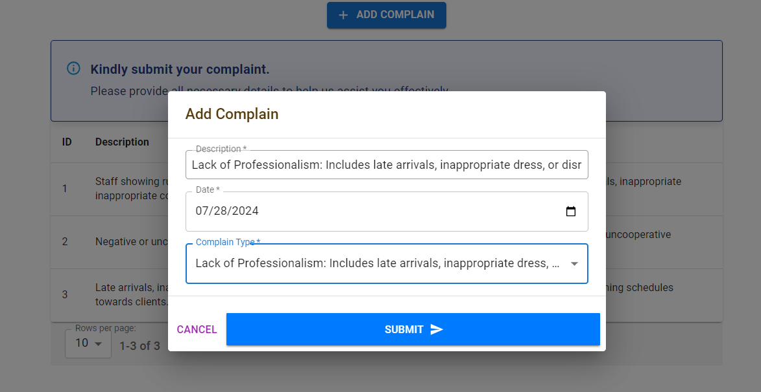

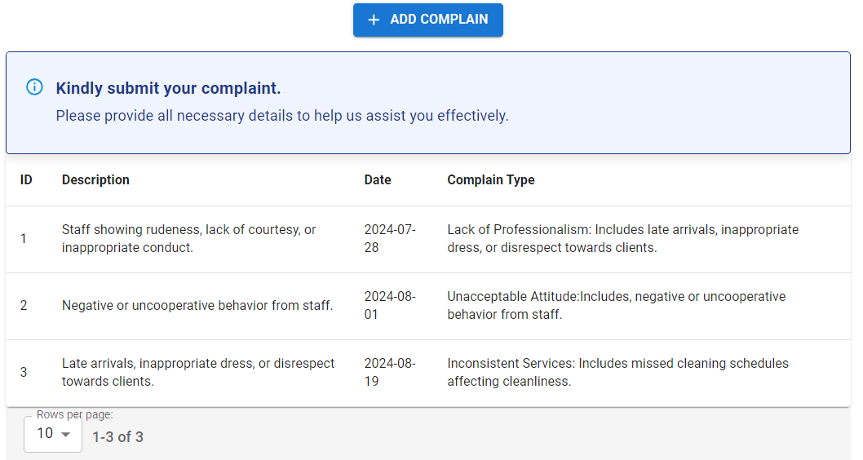

**User Interfaces**

Is an interface where a user interacts with the website they’re using. It provides a pictorial representation of most important user interfaces of the main functionalities of the system.

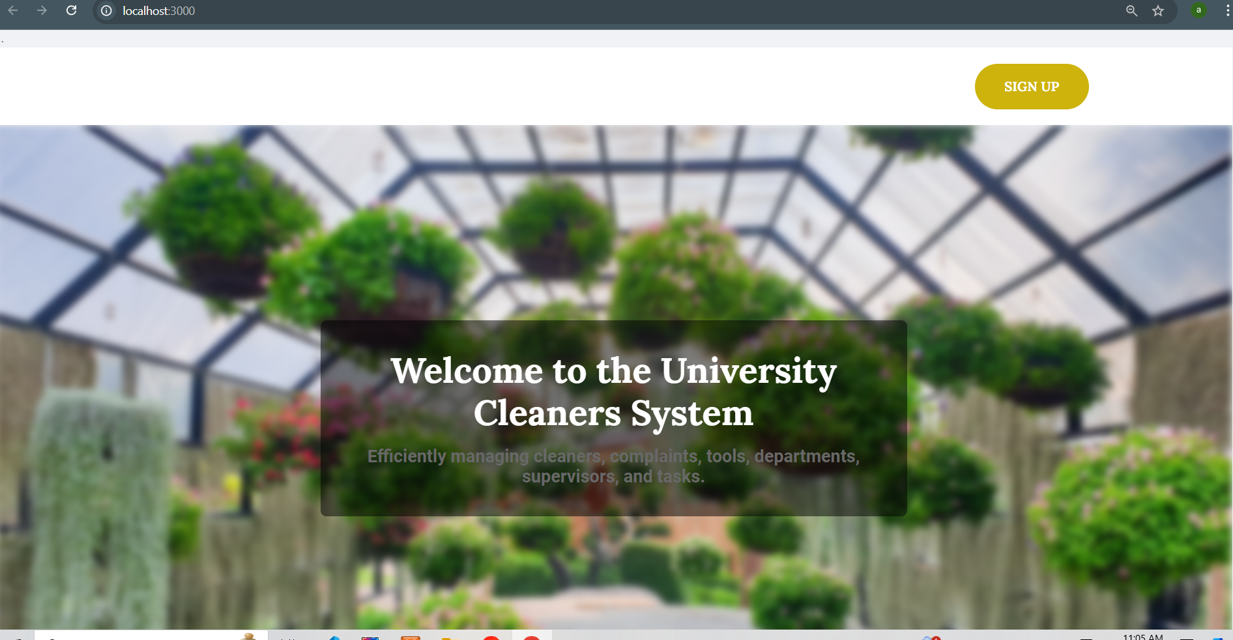

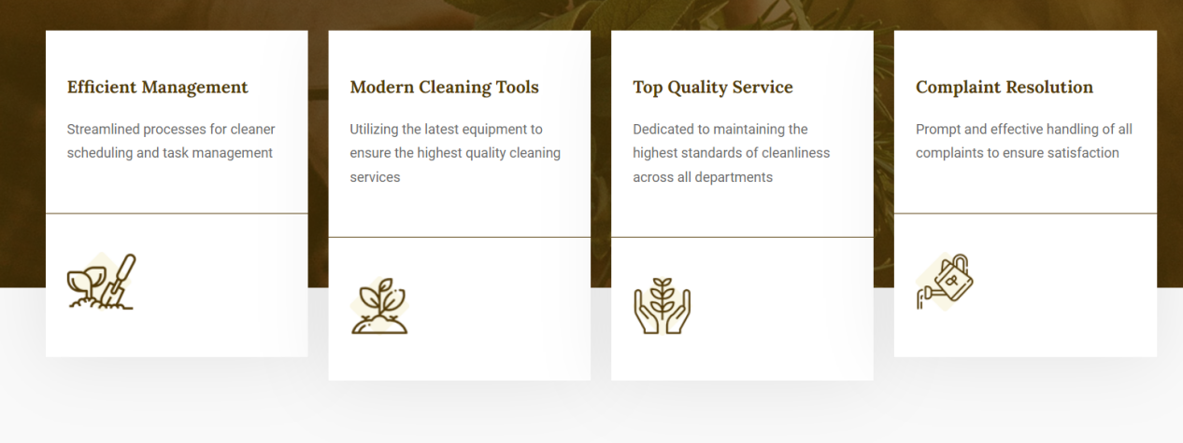

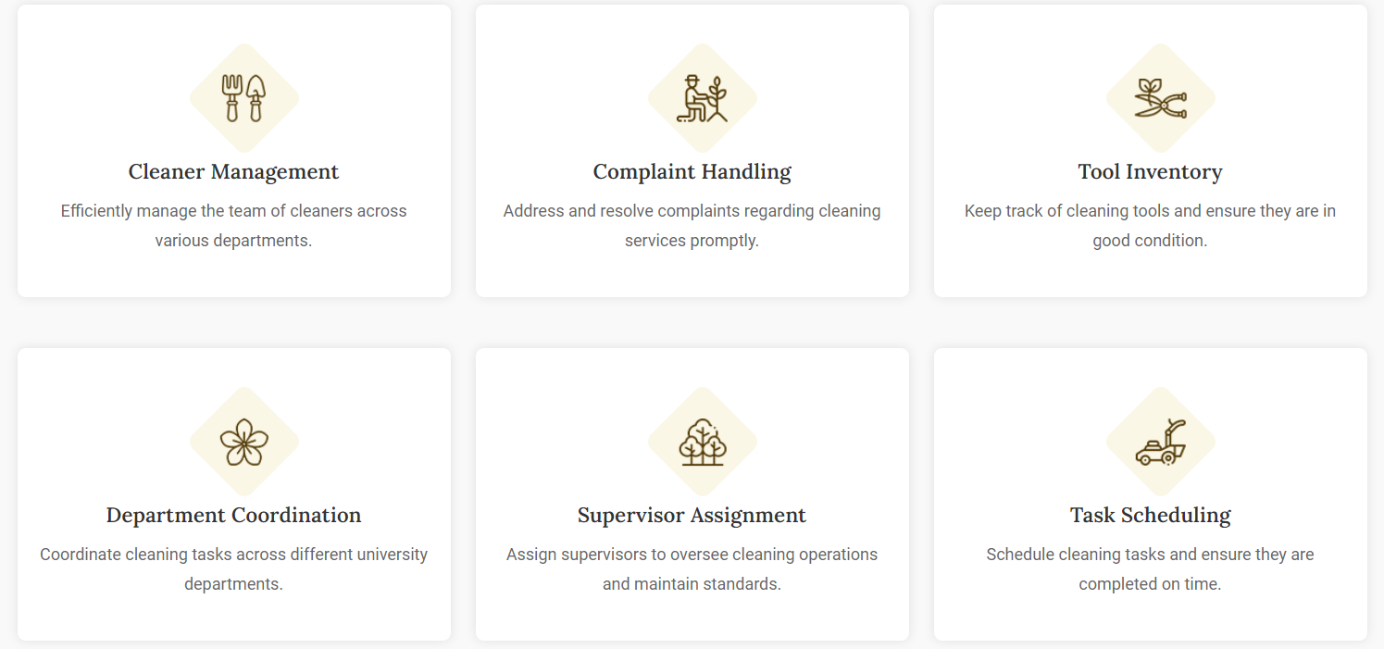

**Report form**

**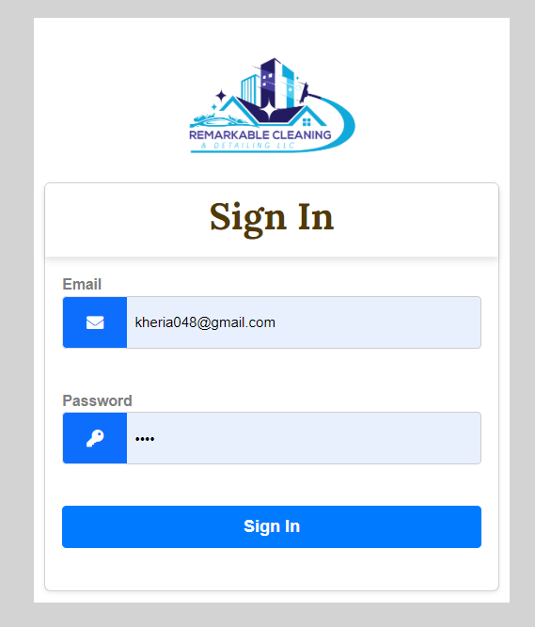**

**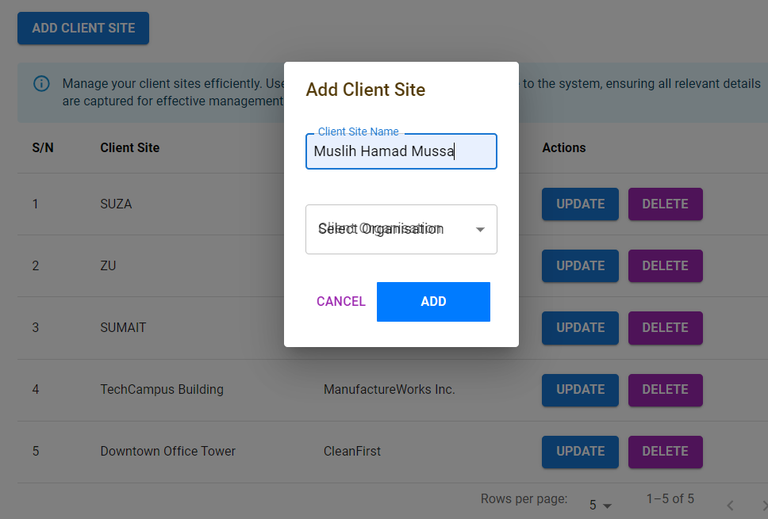**

**Admin Member Area**

**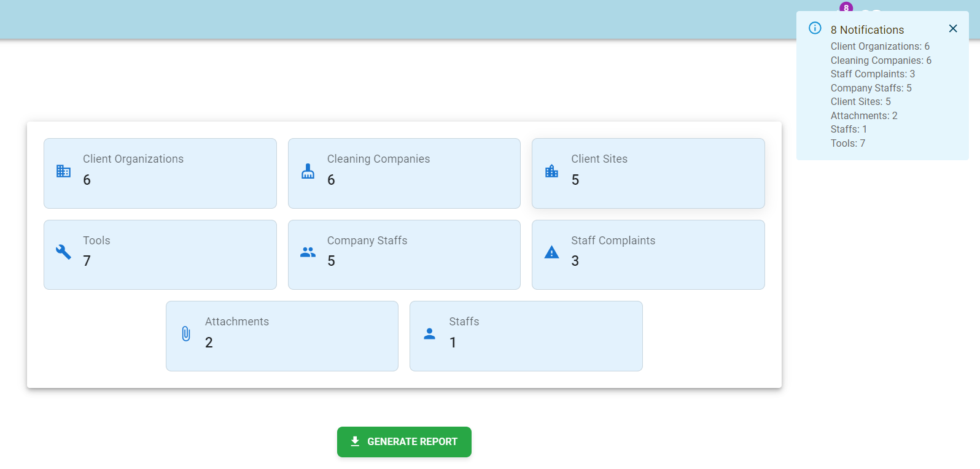**

**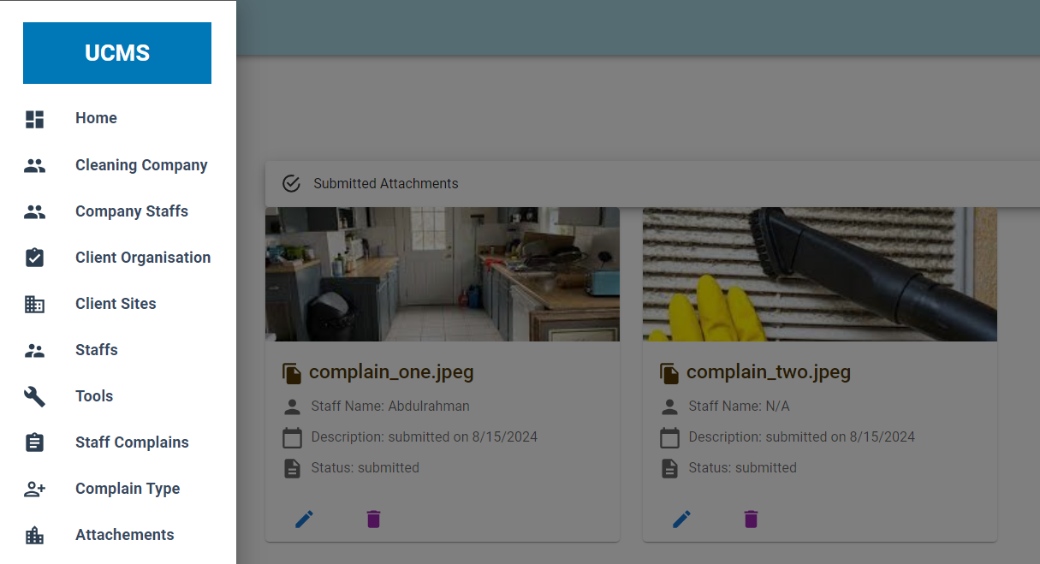**

**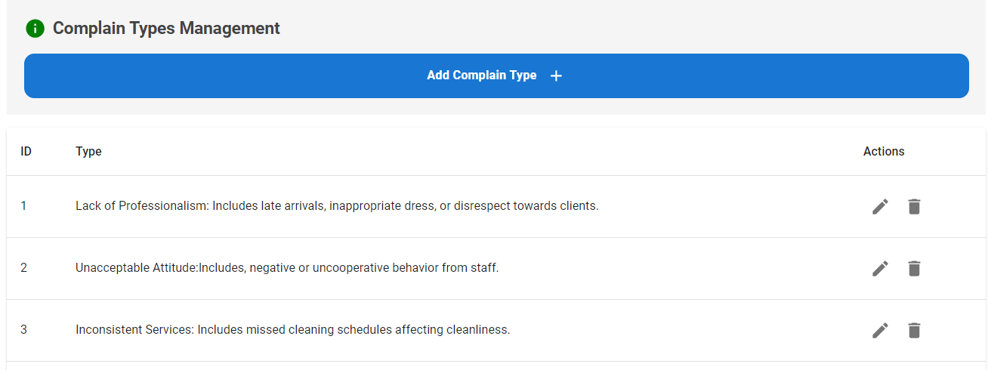**

**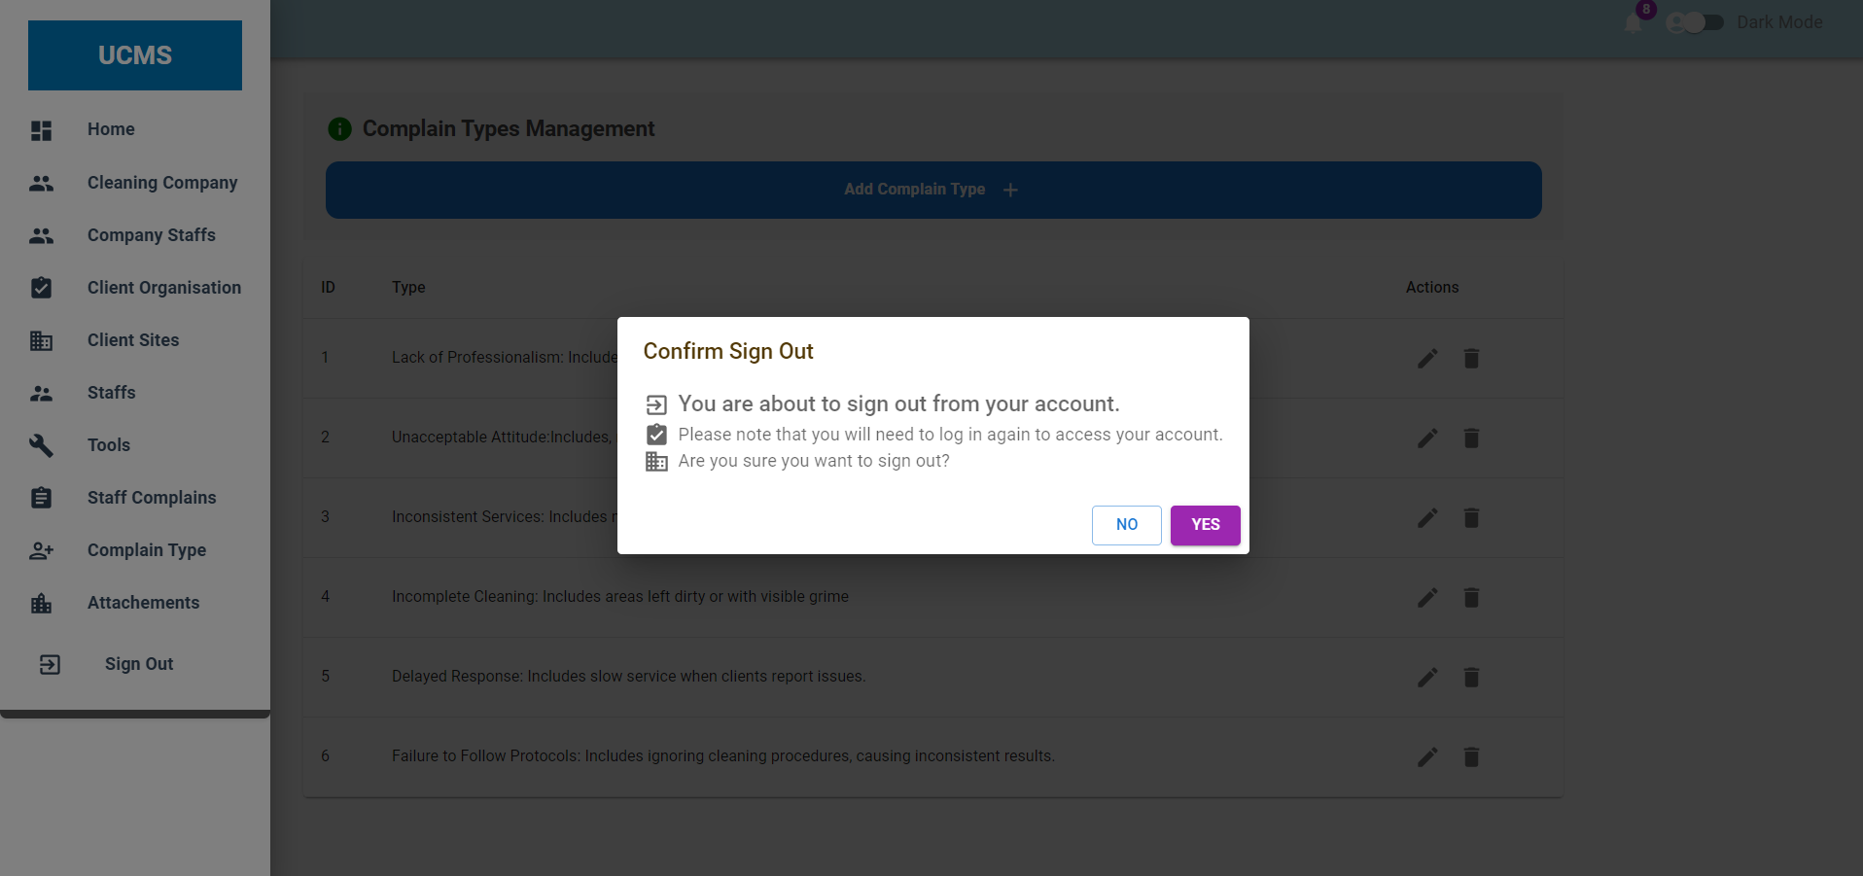**

**Strength and Limitation of the system**

**What is covered from requirements**

In this project, most of the requirement as mentioned above include functional requirements and non-functional requirements have been covered.

###### What is not covered

I have not covered the part of providing feedback for the complains that have been submitted by the staff in a client site

###### CHAPTER 6

**Conclusion, Recommendations, Challenges, and References**

###### Conclusion

The University Cleaners Management System (UCMS) facilitates seamless integration of cleaning services by fostering relationships among cleaning companies, client organizations, and client sites. Additionally, it enhances the management and resolution of complaints from staff regarding the cleaning services provided by the organization. The UCMS ensures efficient communication and coordination, thereby improving the overall quality of cleaning services and satisfaction levels among stakeholders.

###### Recommendations

It is recommended that client organizations prioritize the resolution of complaints submitted by staff at client sites. This proactive approach will significantly enhance the quality of cleaning services and adoptive positive work environment. Addressing staff concerns promptly and effectively is essential for maintaining high standards of cleanliness and operational efficiency.

**Challenges**

Challenges are an inevitable part of any project. Throughout the development of the UCMS, several challenges were encountered:

· **Integration Complexity**: Coordinating backend and frontend systems required careful planning to ensure seamless communication between all components.

* **Data Management**: Managing large volumes of data on cleaning schedules, staff, and complaints demanded strict accuracy and consistency.

· **Customization and Scalability**: Creating a flexible and scalable system to meet diverse client needs involved balancing customization with functionality.

· **Security and Privacy**: Ensuring the protection of sensitive data required implementing strong security measures to prevent breaches and unauthorized access.

· **User Adoption**: Transitioning users to the new system required thorough training and support to ease the change from existing processes.

###### References

Garry, B. S., & Rosenblatt, H. J. (Ninth Edition). System Analysis and Design (9th ed.). United States: Nicole Pinard.

Paradigm, V. (2017, September 25). Conceptual, Logical and Physical Data Model. Visual Paradigm. [https://cs.visual-paradigm.com/](https://cs.visual-paradigm.com/" \t "_new)

Robin, N. (2000). Learning PHP, MySQL, and JavaScript. Sebastopol, California: O’Reilly Media.

Sami, M. (2012, March 15). Software Development Life Cycle Models and Methodologies. Mohamed Sami Personal Website – Software Engineering.

Valacich, J. S., & George, J. F. (2017). Modern System Analysis and Design. United States of America: Pearson Education Inc.